Assignment-01

BASIC ELECTRICAL & ELECTRONICS ENGINEERING

How much current will flow through a 10-V battery with a 100-Ω resistor connected across its terminals?

- 0.1 A (b)1.0 A (c) 0 A (d) 1,000 A

2. Three resistance of 15Ω each are connected in delta. Calculate total equivalent resistance of equivalent star will have a value of
(a) 12Ω (b) 5Ω (c) 5/3Ω (d) 45Ω

3. Find total current (mA) in the circuit.

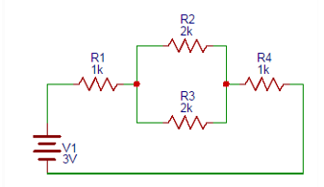

4. Calculate the voltage across the 10 ohm resistor.
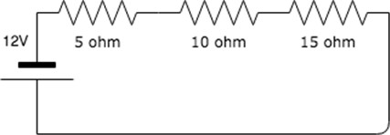

5.. A resistor of 5 Ω is connected across a potential difference of 100V.Calculate the power dissipated and energy transferred to heat in 2 minutes?

6.. Using Nodal analysis method, determine the voltages Va & Vb and current through the 6 ohm resistance.
